Question 8

Use Linux to view the MAC address table of a switch (if using a Linux-based network switch). Use the bridge or ip link commands to inspect the MAC table and demonstrate a basic switch's operation.

Approach

Here we are using three linux Virtual Machine in GNS3 one as Switch and another two as host. First configure the virtual machine in virtual box by changing the network setting. Enable two internal adaptor and one bridged or NAT adapter for wifi (Make sure that bridge adapter is cable connected)

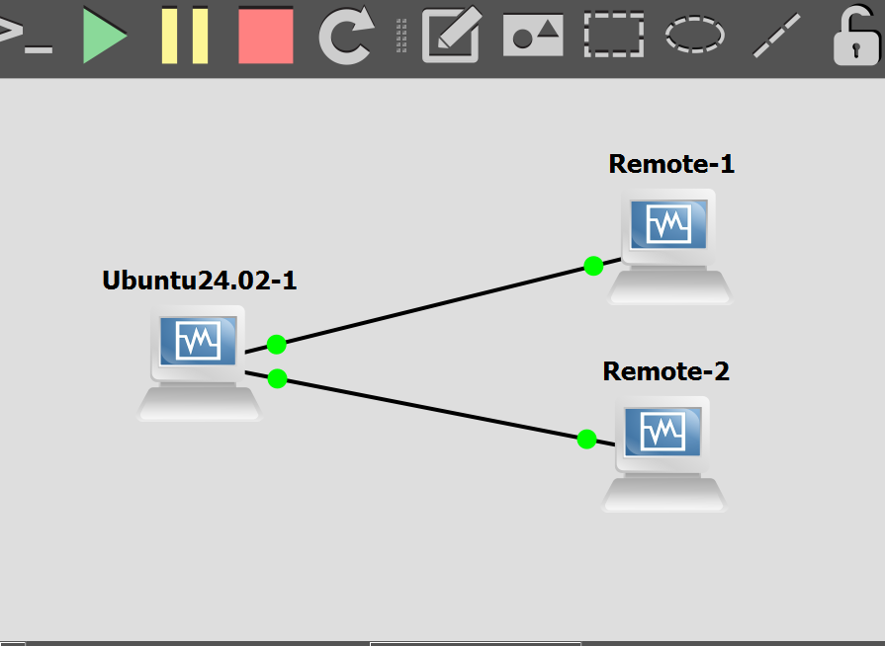

Once you done that start the connection and download bridge-utils package.

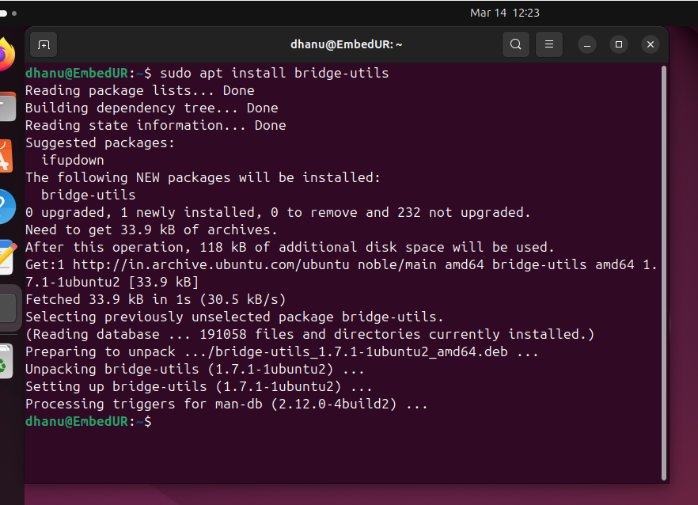

Once done, now we need to set bridge on the linux (which act as ubuntu). Type ifconfig you may see 4 ports

Lo, enp0s3,enp0s8,enp0s9 (the last three may differ)

Now set the bridge (br0) by following brctl command and add enp0s8 and enp0s9 to the bridge br0

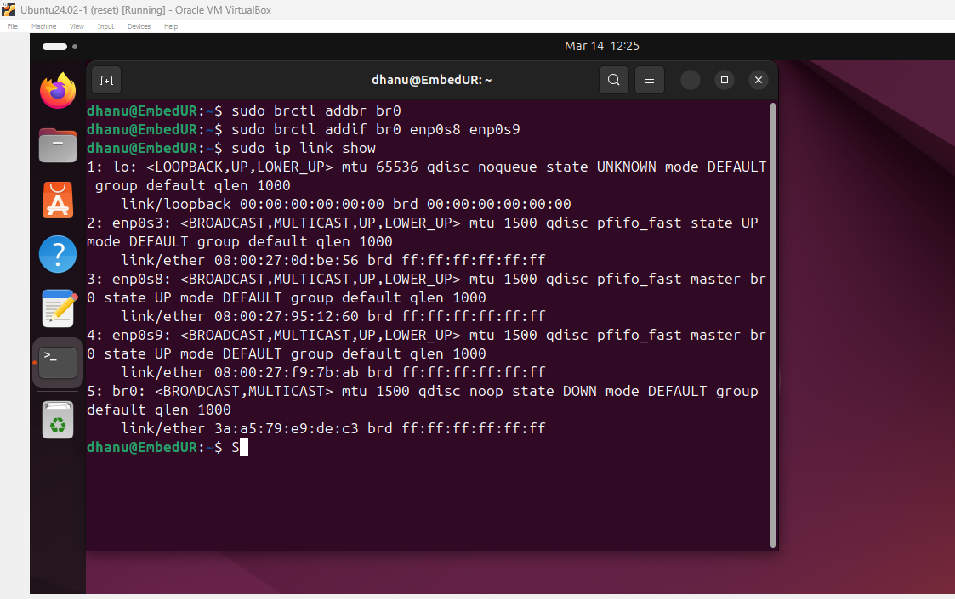

Once done set your ip link br0 up. Other two are up by default if not do it. To check the up status use ip link show command

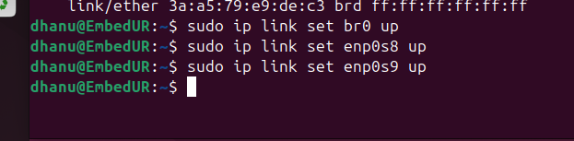

Now go to two host and disable and stop the NetworkManager to assign staticIP

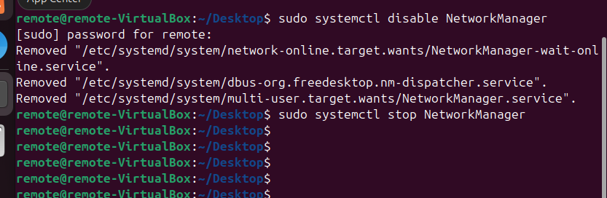

Once done set the static ip. Make sure to have ip in same class and subnet.

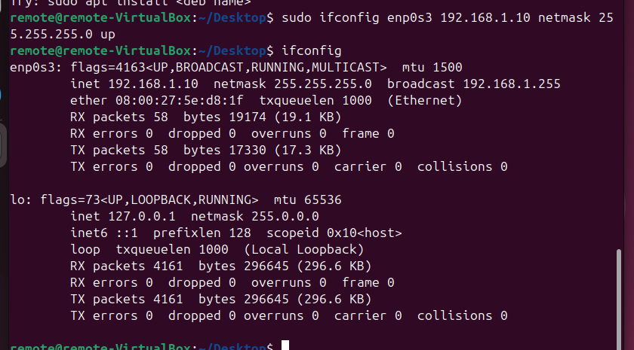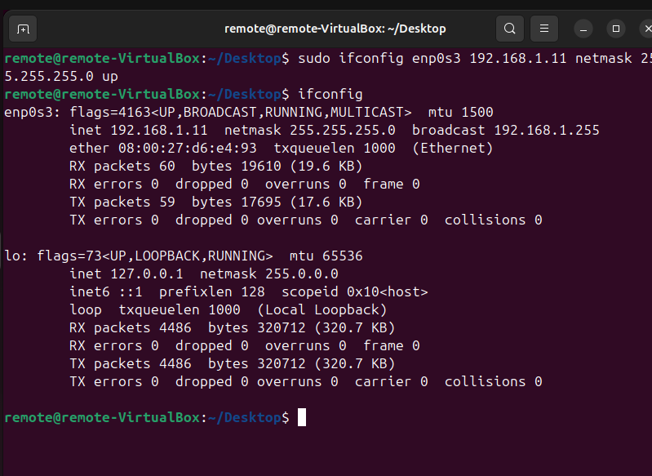

Now try to ping pc two from pc one. You can able to ping it successfully

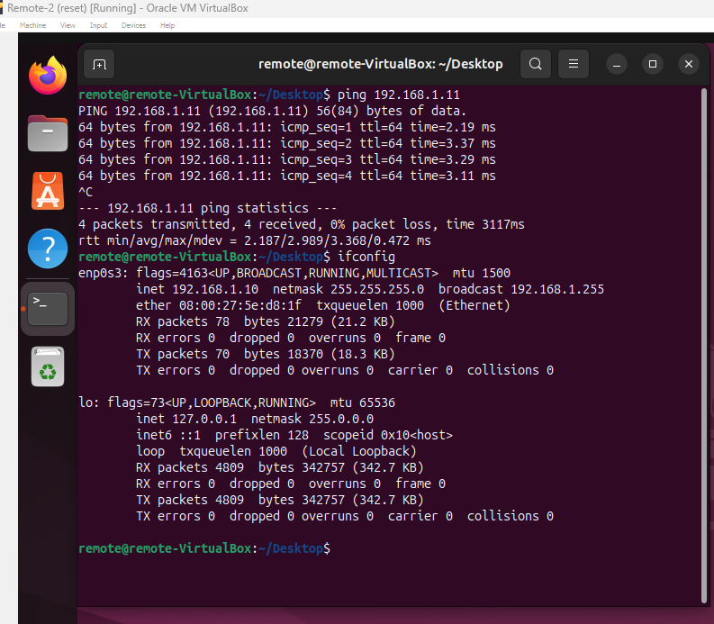

In the above image I was able to ping 192.168.1.11 from 192.168.1.10

Since it is a linux based switch now let’s try to see the mac address table from bridge command.

bridge fdb show

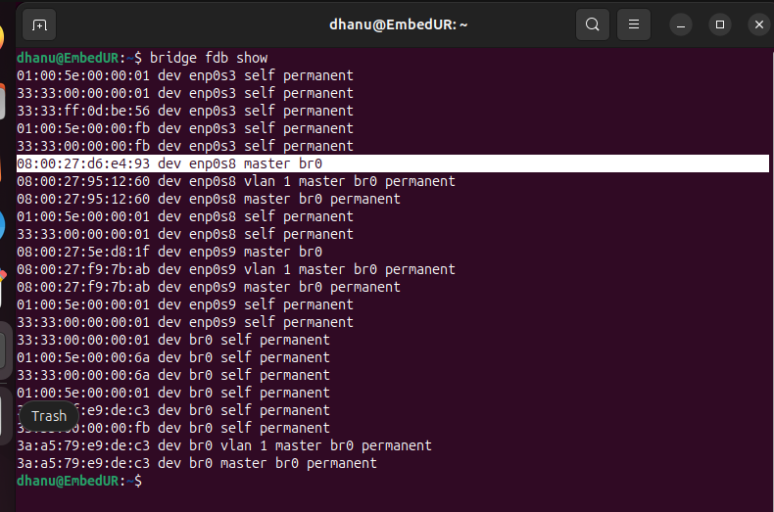

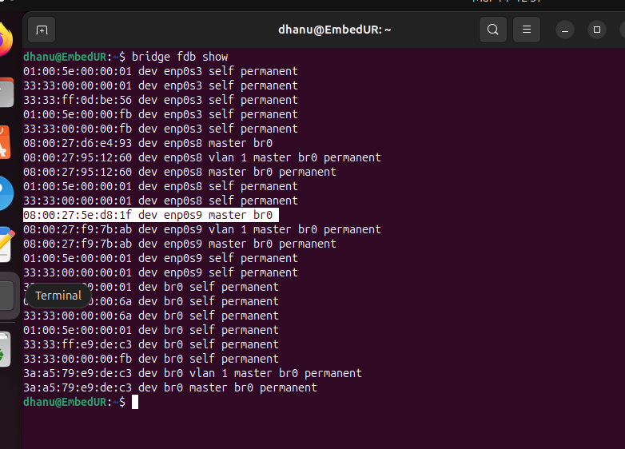  
We can confirm that two pc Mac address are in the switch’s forwarding database table